<li class="dropdown-header">Dropdown header 1</li>

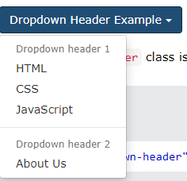

<!DOCTYPE html>

<html>

<head>

<meta name="viewport" content="width=device-width, initial-scale=1">

<link rel="stylesheet" href="https://maxcdn.bootstrapcdn.com/bootstrap/3.4.1/css/bootstrap.min.css">

<script src="https://ajax.googleapis.com/ajax/libs/jquery/3.5.1/jquery.min.js"></script>

<script src="https://maxcdn.bootstrapcdn.com/bootstrap/3.4.1/js/bootstrap.min.js"></script>

</head>

<body>

<div class="container">

<div class="dropdown">

<button class="btn btn-default dropdown-toggle" type="button" data-toggle="dropdown">Tutorials

<span class="caret"></span></button>

<ul class="dropdown-menu">

<li class="dropdown-header">Dropdown header 1</li>

<li><a href="#">HTML</a></li>

<li><a href="#">CSS</a></li>

<li><a href="#">JavaScript</a></li>

<li class="divider"></li>

<li class="dropdown-header">Dropdown header 2</li>

<li><a href="#">About Us</a></li>

</ul>

</div>

</div>

</body>

</html>